For Those Near, the Miserable Hum of Clean Energy
By TOM ZELLER Jr.OCT. 5, 2010
Art Lindgren measured noise levels at a wind turbine near Vinalhaven, Me. He and neighbors say the turbines have robbed their community of its tranquility. Credit Matt McInnis for The New York Times
VINALHAVEN, Me. — Like nearly all of the residents on this island in Penobscot Bay, Art Lindgren and his wife, Cheryl, celebrated the arrival of three giant wind turbines late last year. That was before they were turned on.
“In the first 10 minutes, our jaws dropped to the ground,” Mr. Lindgren said. “Nobody in the area could believe it. They were so loud.”
Now, the Lindgrens, along with a dozen or so neighbors living less than a mile from the $15 million wind facility here, say the industrial whoosh-and-whoop of the 123-foot blades is making life in this otherwise tranquil corner of the island unbearable.
They are among a small but growing number of families and homeowners across the country who say they have learned the hard way that wind power — a clean alternative to electricity from fossil fuels — is not without emissions of its own.
Lawsuits and complaints about turbine noise, vibrations and subsequent lost property value have cropped up in Illinois, Texas, Pennsylvania, Wisconsin and Massachusetts, among other states.

TIMES TOPIC

Wind Power
video

The Fight Over Wind Power in Vinalhaven OCT. 5, 2010

Recent Comments

ERhoades
October 6, 2010
While turbines must be engineered so that people can exist near them I feel that too often people feel the need for something but don't want...

Blue
October 6, 2010
OK, never mind...I take it back...sounds like they are making a mountain out of a molehill.

Blue
October 6, 2010
Ok, first let me say that I am an ardent supporter of wind power and would like to see a lot more of it.However, I live near a busy highway...
- See All Comments
In one case in DeKalb County, Ill., at least 38 families have sued to have 100 turbines removed from a wind farm there. A judge rejected a motion to dismiss the case in June.
Like the Lindgrens, many of the people complaining the loudest are reluctant converts to the antiwind movement.
“The quality of life that we came here for was quiet,” Mrs. Lindgren said. “You don’t live in a place where you have to take an hour-and-15-minute ferry ride to live next to an industrial park. And that’s where we are right now.”
The wind industry has long been dogged by a vocal minority bearing all manner of complaints about turbines, from routine claims that they ruin the look of pastoral landscapes to more elaborate allegations that they have direct physiological impacts like rapid heart beat, nausea and blurred vision caused by the ultra-low-frequency sound and vibrations from the machines.
For the most extreme claims, there is little independent backing.
Last year, the American Wind Energy Association, a trade group, along with its Canadian counterpart, assembled a panel of doctors and acoustical professionals to examine the potential health impacts of wind turbine noise. In a paper published in December, the panel concluded that “there is no evidence that the audible or sub-audible sounds emitted by wind turbines have any direct adverse physiological effects.”
A separate study financed by the Energy Department concluded late last year that, in aggregate, property values were unaffected by nearby wind turbines.
Numerous studies also suggest that not everyone will be bothered by turbine noise, and that much depends on the context into which the noise is introduced. A previously quiet setting like Vinalhaven is more likely to produce irritated neighbors than, say, a mixed-use suburban setting where ambient noise is already the norm.
Photo
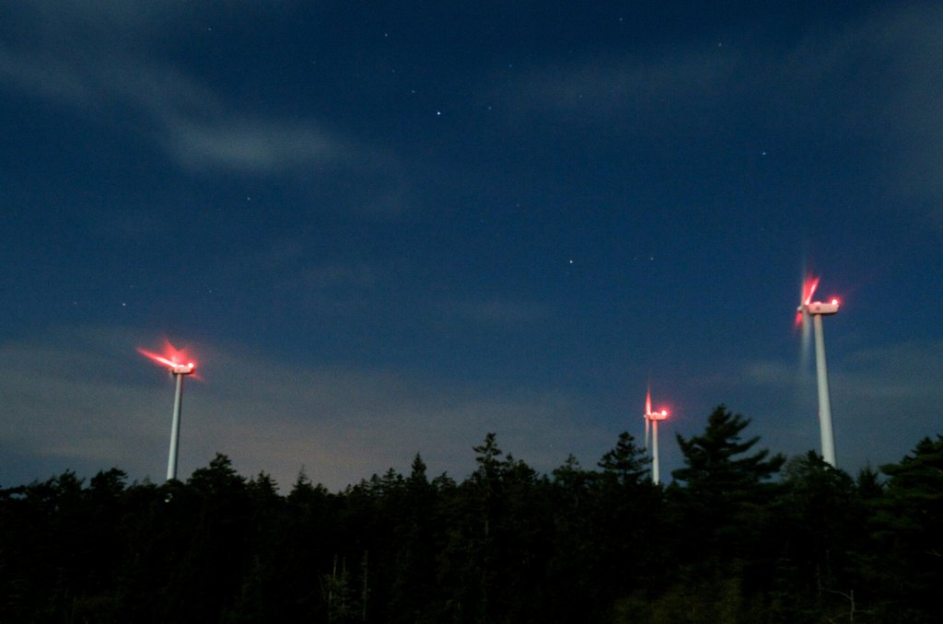
Residents living less than a mile from the $15 million wind facility in Vinalhaven, Me., say the industrial whoosh-and-whoop of the 123-foot blades is making life unbearable. Credit Matt McInnis for The New York Times
Of the 250 new wind farms that have come online in the United States over the last two years, about dozen or so have generated significant noise complaints, according to Jim Cummings, the founder of the Acoustic Ecology Institute, an online clearinghouse for information on sound-related environmental issues.
In the Vinalhaven case, an audio consultant hired by the Maine Department of Environmental Protection determined last month that the 4.5-megawatt facility was, at least on one evening in mid-July when Mr. Lindgren collected sound data, in excess of the state’s nighttime sound limits. The developer of the project, Fox Island Wind, has contested that finding, and negotiations with state regulators are continuing.
In the moonlit woods behind a neighbor’s property on a recent evening, Mr. Lindgren, a retired software engineer, clenched a small flashlight between his teeth and wrestled with a tangle of cables and audio recording equipment he uses to collect sound samples for filing complaints.

Newsletter Sign Up
Continue reading the main story

Sign up for the all-new DealBook newsletter
Our columnist Andrew Ross Sorkin and his Times colleagues help you make sense of major business and policy headlines — and the power-brokers who shape them.

You agree to receive occasional updates and special offers for The New York Times's products and services.

- See Sample
- Privacy Policy
- Opt out or contact us anytime
At times, the rustle of leaves was all that could be heard. But when the surface wind settled, a throbbing, vaguely jetlike sound cut through the nighttime air. “Right there,” Mr. Lindgren declared. “That would probably be out of compliance.”
Maine, along with many other states, puts a general limit on nighttime noise at 45 decibels — roughly equivalent to the sound of a humming refrigerator. A normal conversation is in the range of 50 to 60 decibels.
In almost all cases, it is not mechanical noise arising from the central gear box or nacelle of a turbine that residents react to, but rather the sound of the blades, which in modern turbines are mammoth appendages well over 100 feet long, as they slice through the air.
Turbine noise can be controlled by reducing the rotational speed of the blades. But the turbines on Vinalhaven already operate that way after 7 p.m., and George Baker, the chief executive of Fox Island Wind — a for-profit arm of the island’s electricity co-operative — said that turning the turbines down came at an economic cost.
“The more we do that, the higher goes the price of electricity on the island,” he said.
A common refrain among homeowners grappling with sound issues, however, is that they were not accurately informed about the noise ahead of time. “They told us we wouldn’t hear it, or that it would be masked by the sound of the wind blowing through the trees,” said Sally Wylie, a former schoolteacher down the road from the Lindgrens. “I feel duped.”
Similar conflicts are arising in Canada, Britain and other countries. An appeals court in Rennes, France, recently ordered an eight-turbine wind farm to shut down between 10 p.m. and 7 a.m. so residents could get some sleep.
Richard R. James, an acoustic expert hired by residents of Vinalhaven to help them quantify the noise problem, said there was a simpler solution: do not put the turbines so close to where people live.
“It would seem to be time for the wind utility developers to rethink their plans for duplicating these errors and to focus on locating wind turbines in areas where there is a large buffer zone of about a mile and one-quarter between the turbines and people’s homes,” said Mr. James, the principal consultant with E-Coustic Solutions, based in Michigan.
Vinalhaven’s wind farm enjoys support among most residents, from ardent supporters of all clean energy to those who simply say the turbines have reduced their power bills. Deckhands running the ferry sport turbine pins on their hats, and bumper stickers seen on the island declare “Spin, Baby, Spin.”
“The majority of us like them,” said Jeannie Conway, who works at the island’s ferry office.
But that is cold comfort for Mrs. Lindgren and her neighbors, who say their corner of the island will never be the same.
“I remember the sound of silence so palpable, so merciless in its depths, that you could almost feel your heart stop in sympathy,” she said. “Now we are prisoners of sonic effluence. I grieve for the past.”
Correction: October 7, 2010
An article on Wednesday about the noise of wind turbines misstated the material of which turbine blades are made. They are typically made of fiberglass or plastic reinforced with carbon fiber, not steel.
A version of this article appears in print on October 6, 2010, on Page A1 of the New York edition with the headline: For Those Living Nearby, That Miserable Hum of Clean Energy.

